NAME: RAJA RAYYAN AMEER
REG. NO.: 23-CP-25
SECTION: ALPHA
SUBJECT: DATABASE MANAGEMENT SYSTEM
DEPARTMENT: COMPUTER ENGINEERING
TEACHER: SIR SHAHID
LAB 2
Task 1: Identify Entities from Scenario
Scenario: A university wants to manage data about students, courses, instructors, and enrollments. Identify all possible entities and relationships.
In this task, you will read a case scenario about a university database and highlight potential entities, their attributes, and relationships.
Entities:
- Students.
- Courses.
- Faculty.
- Enrollments.
Task 2: Define Attributes and Identify Primary Keys
In this task, you will define attributes for each entity. Make sure to include primary keys and meaningful field names.
Example: For students – student_id (PK), name, dob, email, program.
- Students
- student_id (PK)
- name
- dob
- email
- program
- Courses
- course_id (PK)
- title
- credit_hours
- Faculty
- faculty_id (PK)
- name
- email
- Enrollments
- student_id (FK → Students)
- course_id (FK → Courses)
- semester
- grade
Task 3: Draw ER Diagram Using Online Tool
In this task, you will design the ER diagram using dbdiagram.io. Use boxes for entities and diamonds for relationships.
Query:
Table students {
student_id int [pk]
name varchar
dob date
email varchar
program varchar
}

Table courses {
course_id int [pk]
title varchar
credit_hours int
}

Table faculty {
faculty_id int [pk]
name varchar
email varchar
}

Table enrollments {
student_id int [ref: > students.student_id]
course_id int [ref: > courses.course_id]
semester varchar
grade varchar
indexes {
(student_id, course_id) [pk]
}
}
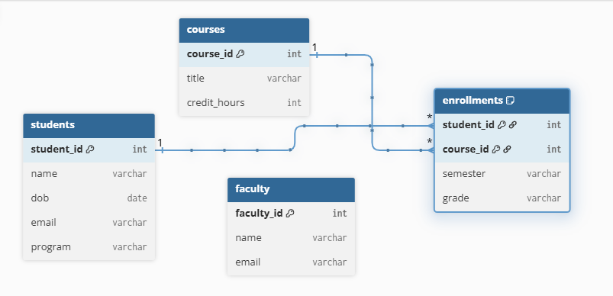
Task 4: Model Relationships with Correct Cardinality
In this task, you will model relationships. Add cardinalities such as 1 : N, M : N to the diagram. Example: One instructor can teach many courses (1 : N), students can enroll in many courses (M : N).


Task 5: Incorporate Weak Entities into ER Diagram
In this task, you will implement weak entities and relationships if applicable.
Example: A 'dependent' entity related to a student may not have an identifier without the owning student.
Query:
Table library_accounts {
account_id int
student_id int [ref: > students.student_id]
issue_date date
expiry_date date
indexes {
(account_id, student_id) [pk]
}
}
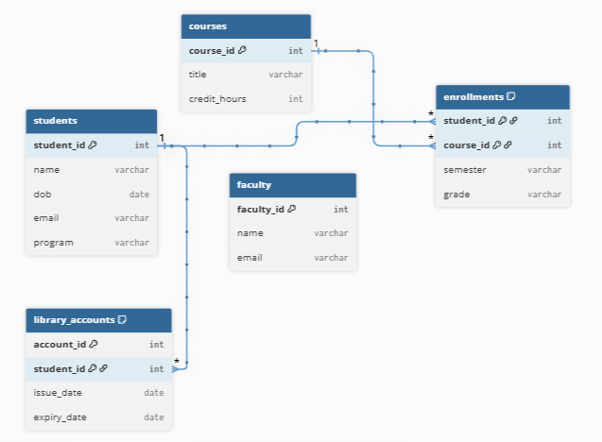
Task 6: Export SQL Schema from ER Tool
In this task, you will export the schema from dbdiagram.io as SQL DDL.
Use the 'Export SQL' option and copy the CREATE TABLE statements to your editor.
Query:
CREATE TABLE students (
student_id INT PRIMARY KEY,
name VARCHAR(100),
dob DATE,
email VARCHAR(100),
program VARCHAR(50)
);

CREATE TABLE courses (
course_id INT PRIMARY KEY,
title VARCHAR(100),
credit_hours INT
);

CREATE TABLE instructors (
instructor_id INT PRIMARY KEY,
name VARCHAR(100),
email VARCHAR(100),
office VARCHAR(50)
);

CREATE TABLE enrollments (
student_id INT,
course_id INT,
semester VARCHAR(10),
grade VARCHAR(5),
PRIMARY KEY (student_id, course_id),
FOREIGN KEY (student_id) REFERENCES students(student_id),
FOREIGN KEY (course_id) REFERENCES courses(course_id)
);
Task 7: Execute SQL Schema in DBMS
In this task, you will paste the exported SQL into your DBMS query editor and execute it to create tables.
Open MySQL Workbench, paste the SQL, and run the script. Confirm success with `SHOW TABLES;`.
Query:
SHOW TABLES;
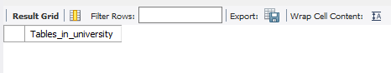

Task 8: Modify Relationships and Regenerate Schema
In this task, you will modify relationships in the ER tool and regenerate the schema.
Try switching an M : N to 1 : N by adding an intermediary entity and regenerating the updated SQL.
Query:
Table enrollments {
student_id int [ref: > students.student_id]
course_id int [ref: > courses.course_id]
semester varchar
grade varchar
indexes {
(student_id, course_id) [pk]
}
}

Task 9: Update Entity Attributes and Reflect in Schema
In this task, you will add attributes to an existing entity and validate the updated schema.
For example, add 'GPA' to 'students' table, re-export the SQL, and apply ALTER TABLE if needed.
Query:
ALTER TABLE students ADD gpa DECIMAL(3,2);
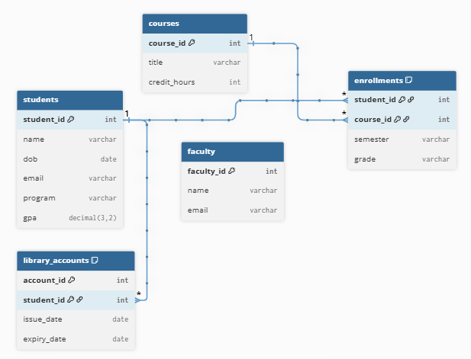
Task 10: Review Final ER Diagram and Generated SQL
In this task, you will review the final ER diagram and corresponding SQL schema for completeness and correctness.
Make sure all entities and relationships are accounted for and SQL matches the ER diagram.
Query:
Table students {
student_id int [pk]
name varchar
dob date
email varchar
program varchar
gpa decimal(3,2)
}

Table courses {
course_id int [pk]
title varchar
credit_hours int
}

Table faculty {
faculty_id int [pk]
name varchar
email varchar
}

Table enrollments {
student_id int [ref: > students.student_id]
course_id int [ref: > courses.course_id]
semester varchar
grade varchar
indexes {
(student_id, course_id) [pk]
}
}

Table library_accounts {
account_id int
student_id int [ref: > students.student_id]
issue_date date
expiry_date date
indexes {
(account_id, student_id) [pk]
}
}

LAB CHALLENGES:
- Add a new entity 'Department' and relate it to both 'students' and 'faculty'.
Query:
Table students {
student_id int [pk]
name varchar
dob date
email varchar
program varchar
gpa decimal(3,2)
dept_id int [ref: > departments.dept_id]
}
Table faculty {
faculty_id int [pk]
name varchar
email varchar
dept_id int [ref: > departments.dept_id]
}

Table departments {
dept_id int [pk]
dept_name varchar
}
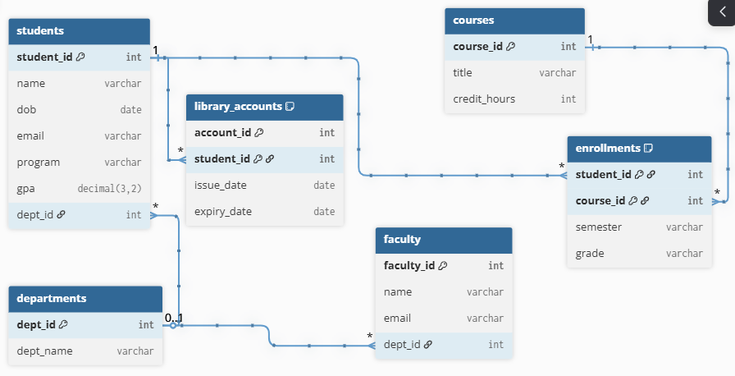
- Design a ternary relationship between student, course, and instructor in the enrollment Context.
Query:
Table enrollments {
student_id int [ref: > students.student_id]
course_id int [ref: > courses.course_id]
faculty_id int [ref: > faculty.faculty_id]
semester varchar
grade varchar
indexes {
(student_id, course_id, faculty_id) [pk]
}
}
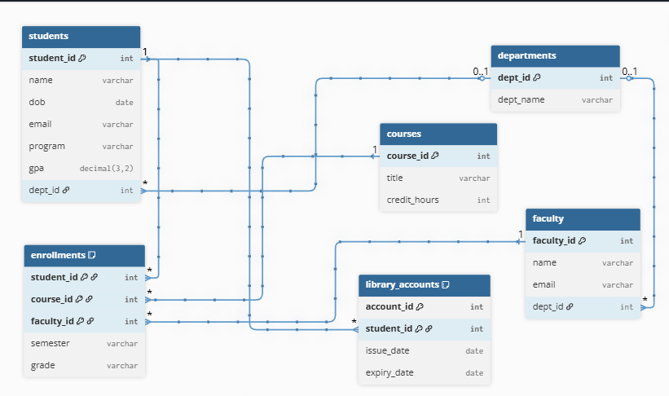
- Include a weak entity 'LibraryAccount' dependent on 'students' and model it properly.
Query:
Table library_accounts {
account_id int
student_id int [ref: > students.student_id]
issue_date date
expiry_date date
indexes {
(account_id, student_id) [pk]
}
}

- Write SQL to enforce a composite primary key in a relationship table.
Query:
CREATE TABLE enrollments (
student_id INT,
course_id INT,
PRIMARY KEY (student_id, course_id),
FOREIGN KEY (student_id) REFERENCES students(student_id),
FOREIGN KEY (course_id) REFERENCES courses(course_id)
);

- Transform an M : N relationship into two 1 : N relationships using a junction table.
Query:
- dbDiagram.io:
Table students {
student_id int [pk]
name varchar
dob date
email varchar
program varchar
gpa decimal(3,2)
dept_id int [ref: > departments.dept_id]
}

Table courses {
course_id int [pk]
title varchar
credit_hours int
}

Table faculty {
faculty_id int [pk]
name varchar
email varchar
dept_id int [ref: > departments.dept_id]
}

Table enrollments {
student_id int [ref: > students.student_id]
course_id int [ref: > courses.course_id]
instructor_id int [ref: > faculty.faculty_id]
semester varchar
grade varchar
indexes {
(student_id, course_id, instructor_id) [pk]
}
}

Table library_accounts {
account_id int
student_id int [ref: > students.student_id]
issue_date date
expiry_date date
indexes {
(account_id, student_id) [pk]
}
}

Table departments {
dept_id int [pk]
dept_name varchar
}
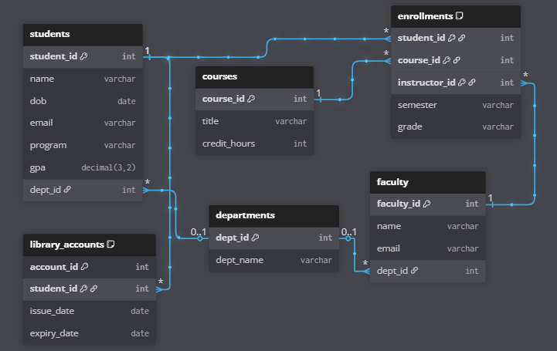

- MySQL:
CREATE TABLE students (
student_id INT PRIMARY KEY,
name VARCHAR(50),
dob DATE,
email VARCHAR(50) UNIQUE,
program VARCHAR(50),
gpa DECIMAL(3,2),
dept_id INT
);

CREATE TABLE courses (
course_id INT PRIMARY KEY,
title VARCHAR(50),
credit_hours int
);

CREATE TABLE faculty (
faculty_id INT PRIMARY KEY,
name VARCHAR(255),
email VARCHAR(255),
dept_id INT
);

CREATE TABLE enrollments (
student_id INT,
course_id INT,
instructor_id INT,
semester VARCHAR(15),
grade CHAR(2),
PRIMARY KEY (student_id, course_id, instructor_id)
);

CREATE TABLE library_accounts (
account_id INT,
student_id INT,
issue_date DATE,
expiry_date DATE,
PRIMARY KEY (account_id, student_id)
);

CREATE TABLE departments (
dept_id INT PRIMARY KEY,
dept_name VARCHAR(255)
);

ALTER TABLE students
ADD FOREIGN KEY (dept_id)
REFERENCES departments (dept_id);

ALTER TABLE faculty
ADD FOREIGN KEY (dept_id)
REFERENCES departments (dept_id);

ALTER TABLE enrollments
ADD FOREIGN KEY (student_id)
REFERENCES students (student_id);

ALTER TABLE enrollments
ADD FOREIGN KEY (course_id)
REFERENCES courses (course_id);

ALTER TABLE enrollments
ADD FOREIGN KEY (instructor_id)
REFERENCES faculty (faculty_id);

ALTER TABLE library_accounts
ADD FOREIGN KEY (student_id)
REFERENCES students (student_id);
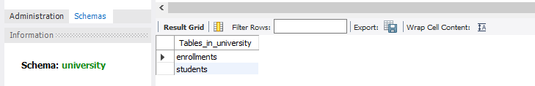
THE END

